OFFICIAL COORDINATION REQUEST FOR
NON-ROUTINE OPERATIONS AND MAINTENANCE

COORDINATION TITLE: 13BON34 WS LFS ROV inspection
COORDINATION DATE- 3 July 2013
PROJECT- Bonneville Lock and Dam
RESPONSE DATE- ASAP

Description of the problem- The Corps proposes to perform an ROV inspection of the new Lamprey Flume System (LFS) at the Washington Shore Fish Ladder on July 11 to investigate whether there were any openings in the LFS that might attract and entrain salmon or other fish. Between June 7 and June 19, several people reported seeing large boils of water and air emanating from the LFS. Further review suggested that there was more entrained air in the gravity water supply system than was anticipated and that the large boil occurred when the valve controlling the water supply was set at approximately 70%-100% open (highest flow settings). Review of video submitted by Bonneville Project Fisheries showed that the boil consistently appeared at the surface above a particular section of the LFS (Figures 1 and 2).

On 20 June, the Corps shut down the LFS due to concerns that the boil appeared too large to be weeping from closed access hatches and thus may be coming from an open hatch or a damaged/compromised section of the LFS. The concern was that any larger openings could attract and entrain salmon, steelhead, or shad and cause a serious passage problem.

An unplanned ROV inspection was completed on June 26, but due to flow conditions, the Corps was unable to verify whether there were openings in the LFS. Based on lessons learned from the June 26 operation, the Corps developed the following proposed plan for the follow-up inspection:

- Proposed special unit operations at Powerhouse 2 for up to 3 hours (approx. 13:00-16:00), as developed by S. Schlenker:
  - Unit 13 @ 15 kcfs
  - Unit 14 @ 12 kcfs
  - Unit 17 or 18 @ 12 kcfs
- FFU Osprey research boat will motor up to the LFS Upper Flume and tie off to the structure. The boat will be shut down during the inspection.
- Although the expectation is that NO special operations will be needed (no NUE or NDE closures), the Corps requests the option to close NUE for up to 3 hours (approx. 13:00-16:00) if necessary.
- A micro ROV will be deployed and retrieved from the boat into the LFS via an access hatch in the upper flume section (Figure 1). A small generator onboard the boat will provide power for the ROV.
- The system to be deployed does not have recording capability, so Corps staff will monitor and take notes during the inspection.

Type of outage required- Operation of a boat within 50 ft of a fishway entrance and possible temporary disruption of normal adult fish ladder operations (NUE closure).

Impact on facility operation- The inspection may require temporary closure of the North Upstream Entrances (NUE) of the Washington Shore Fish Ladder and will require special PH2 main unit operations (see above).

Length of time for repairs- Up to 3 hours (approx. 13:00 – 16:00) on July 11.

Expected impacts on fish passage- The proposed operation coincides with summer upstream migration of Chinook, summer steelhead, sockeye, and Pacific Lamprey (Table 1). The Corps anticipates that this inspection will not impact normal fishway operations, aside from operation of a boat near the NUE. However, as noted above, tailrace conditions may require temporary closure of NUE. Due to the short duration, the time of year (no sea lion predation), and the fact that powerhouse FOGs and both south entrances and the North Downstream Entrance (NDE) will continue operating during the ROV inspection, there will likely little impact on adult salmonids or lamprey as a result of the operation.

Comments from Bonneville Project Fisheries-

Comments from agencies-
USFWS
-----Original Message-----
From: Wills, David [mailto:david_wills@fws.gov]
Sent: Wednesday, July 03, 2013 4:05 PM
To: Mackey, Tammy M NWP
Subject: Re: FPOM: official coordination MOC 13BON34 WS lamprey flume ROV inspection (UNCLASSIFIED)

Tammy,
I support the request for the special ROV inspection of the Washington Shore LFS. It is imperative to determine the extent of the problem and decide if a relatively simple fix is possible or if the structure needs to be shut down for the remainder of the season because it poses a danger, or some other action could be taken.

David Wills
U.S. Fish & Wildlife Service
Columbia River Fisheries Program Office
NWD
-----Original Message-----
From: Dykstra, Timothy A NWD
Sent: Wednesday, July 03, 2013 5:47 PM
To: Wills, Dave
Cc: Klatte, Bernard A NWP; Mackey, Tammy M NWP
Subject: Re: FPOM: official coordination MOC 13BON34 WS lamprey flume ROV inspection (UNCLASSIFIED)
Agreed! Thanks Dave.
Happy 4th!
Tim

CRITFC
-----Original Message-----
From: Tom Lorz [mailto:lort@critfc.org]
Sent: Wednesday, July 03, 2013 4:26 PM
To: Mackey, Tammy M NWP
Subject: Re: FPOM: official coordination MOC 13BON34 WS lamprey flume ROV inspection (UNCLASSIFIED)

I can live with this as long as we keep the other ladders running, since last time it appeared that we may have turned of the fish units?? If that is correct we would not be in support of the operation. If we can keep all the rest of the adult entrances running I can live with a 3 hour outage of NUE espically if we can keep NDE operating.

tom lorz
CRITFC

NOAA FISHERIES
-----Original Message-----
From: Gary Fredricks - NOAA Federal [mailto:gary.fredricks@noaa.gov]
Sent: Friday, July 05, 2013 2:25 PM
To: Mackey, Tammy M NWP; Tackley, Sean C NWP
Cc: Trevor Conder - NOAA Federal; Wills, Dave; Lorz, Tom
Subject: Re: FPOM: official coordination MOC 13BON34 WS lamprey flume ROV inspection (UNCLASSIFIED)

Sean, Tammy, The proposed operation sounds ok, however, let's make sure everyone sticks to the proposed operation, at least in terms of modifications that might take the adult ladder system further out of criteria. I looked closely at the system when I was out there today and didn't see the boils and air bubbles that I have seen in the past. Hide and seek problems are the worst. By the way, I have some pretty detailed video of the "problem" as well, if anyone wants it. It's a very large (100's of megabytes) file. Thanks, Gary

Final results- The inspection is scheduled to occur at 1300 on 11 July.

-----Original Message-----
From: Tackley, Sean C NWP
Sent: Friday, July 12, 2013 8:37 AM
To: Mackey, Tammy M NWP; Brian McIlraith; Statler, Dave; Caudill, Christopher; Mary Moser; Bob Rose; Aaron Jackson; jgraham@wstribes.org; Gary Fredricks - NOAA Federal; Trevor Conder - NOAA Federal; Wills, Dave; Tom Lorz; Hausmann, Ben J NWP; Bissell, Brian M NWP; Royer, Ida M NWP; Langeslay, Mike J NWP; Klatte, Bernard A NWP; Van-der-leeuw, Bjorn NWP; Richards, Natalie A NWP; Welton, Brent C NWP; Zorich, Nathan A NWP; Juhnke, Steve D NWW; BPA Scott Bettin; Wright, Lisa NWD; Johnson, Eric; noah.hubbard@gmail.com
Cc: Perletti, Kevin P NWP; Carroll, Jerry A NWP; Manny, D. Todd NWP; Thomas, Jon B NWP; Schwartz, Dennis E NWP; Mettler, Rick A NWP; Casey, Joyce E NWP
Subject: BON WA Shore lamprey flume ROV inspection sitrep; *INSPECTION SECURED* (UNCLASSIFIED)
Importance: High

Classification: UNCLASSIFIED
Caveats: NONE

Dear Lamprey Partners,

Please see note below from Todd Manny regarding yesterday's ROV inspection of the BON WA Shore Lamprey Flume System (LFS). The inspection began at about 1:45 pm and was completed by 3:15 pm. We did not have to alter operation of the North Upstream Entrance during the inspection and everything went very smoothly.

The LFS is intact, no large openings were found, and all hatches are secure. We did observe about 1/8-inches (+/-) of daylight in the gaps between flume parts that are connected to the PIT antenna located just upstream of the flow splitter (circled in attached, PIT antenna location is shown as a gap between flume pieces). Given the dimensions of the flume and PIT antennas in this location, this is likely the source of the large boils of air and water under higher LFS flow settings and will have to be addressed in the future so we can test higher flow operations safely. For now, we recommend operating the LFS water supply at approximately 40% (~26 cfs) to avoid this condition.

Beginning at 8:00 this morning (July 12), the LFS and the LPS at the upstream end of the system will be turned back on. The University of Idaho and Bonneville Project staff completed all modifications to the LPS last week (see attached before/after photo PDF), and we are all hopeful that the system attracts and safely collects lamprey.

Special thanks to Todd Manny, Bjorn Van-der-leeuw, Brent Welton, and Bonneville Project staff for supporting and successfully executing this important inspection!

Best Regards,
Sean

Sean C. Tackley
Fish Passage Section
USACE Portland District
Phone: 503-808-4751
Email: sean.c.tackley@usace.army.mil

>^<((((º> >^<((((º>
>^<((((º>
>^<((((º>

-----Original Message-----
From: Manny, D. Todd NWP
Sent: Thursday, July 11, 2013 3:33 PM
To: Tackley, Sean C NWP; Richards, Natalie A NWP; Welton, Brent C NWP; Schwartz, Dennis E NWP; Hausmann, Ben J NWP; Van-der-leeuw, Bjorn NWP; Thomas, Jon B NWP; Perletti, Kevin P NWP
Cc: Mackey, Tammy M NWP; Langeslay, Mike J NWP; 'caudill@uidaho.edu'; Klatte, Bernard A NWP; Moynahan, Kevin NWP; Benoit, Richard A NWP; Schlenker, Stephen J NWP; Bissell, Brian M NWP; Royer, Ida M NWP; Zorich, Nathan A NWP; Wright, Lisa NWD; Stansell, Robert J NWP; Mettler, Rick A NWP; Carroll, Jerry A NWP
Subject: Re: WA Shore lamprey flume ROV inspection sitrep; *INSPECTION SECURED* (UNCLASSIFIED)

All:

WA Shore LFS ROV Inspection is complete and secured as of 1515.

No structural issues found. All inspection hatches and accesses secured. Small +/- 1/8th inch gap in top flange of spool piece located on the down stream end of the lower flume.

The flume is ok to operate at lower flow settings (26 cfs) per Sean Tackley.

This inspection was very successful due to the professional assistance of all involved. The NWP Dive Office would like to thank all BONN Project, FFU and RDP personnel for their support.

Thank you,

Todd

Todd Manny
Diving/ ROV Operations and Safety
US Army Corps of Engineers,
Portland District, CENWP-OD-T
333 SW. 1st Ave. /P.O. Box 2946
Portland, Or 97208-2946
503-808-4334 office
541-554-9726 Blackberry
503-808-4329 fax
David.T.Manny@usace.army.mil

-----Original Message-----
From: Bissell, Brian M NWP
Sent: Friday, July 12, 2013 10:21 AM
To: Tackley, Sean C NWP
Cc: Hausmann, Ben J NWP; Royer, Ida M NWP; Traylor, Andrew NWP
Subject: WA Shore LFS / LPS (UNCLASSIFIED)

Classification: UNCLASSIFIED
Caveats: NONE

Sean,

This morning at approximately 0830 we turned the WA Shore LFS / LPS back on. The valve is at approximately 38% with 26 cfs. Not sure who all needs to be aware so I figured I'd let you forward this information along.

Thanks,

Brian Bissell, Fish Biologist
U.S. Army Corps of Engineers
Bonneville Lock & Dam
Brian.M.Bissell@usace.army.mil
541-374-7984 (Office)

Please email or call with questions or concerns:
Sean C. Tackley
503-808-4751
sean.c.tackley@usace.army.mil

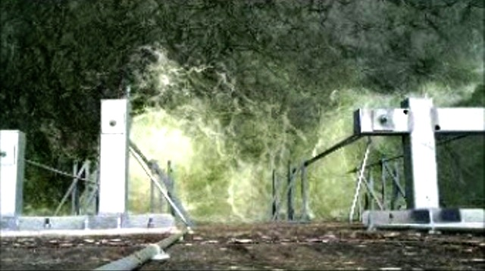

Figure 1. Boil of water and air emanating from the Lamprey Flume System (LFS). This boil appears when the valve controlling water supply to the LFS is set at approximately 70% open or greater. The Corps is concerned that the boil may indicate either an open access hatch or physical damage to the flume, either of which would pose a fish passage risk. The purpose of the ROV inspection was to verify that this is not the case.

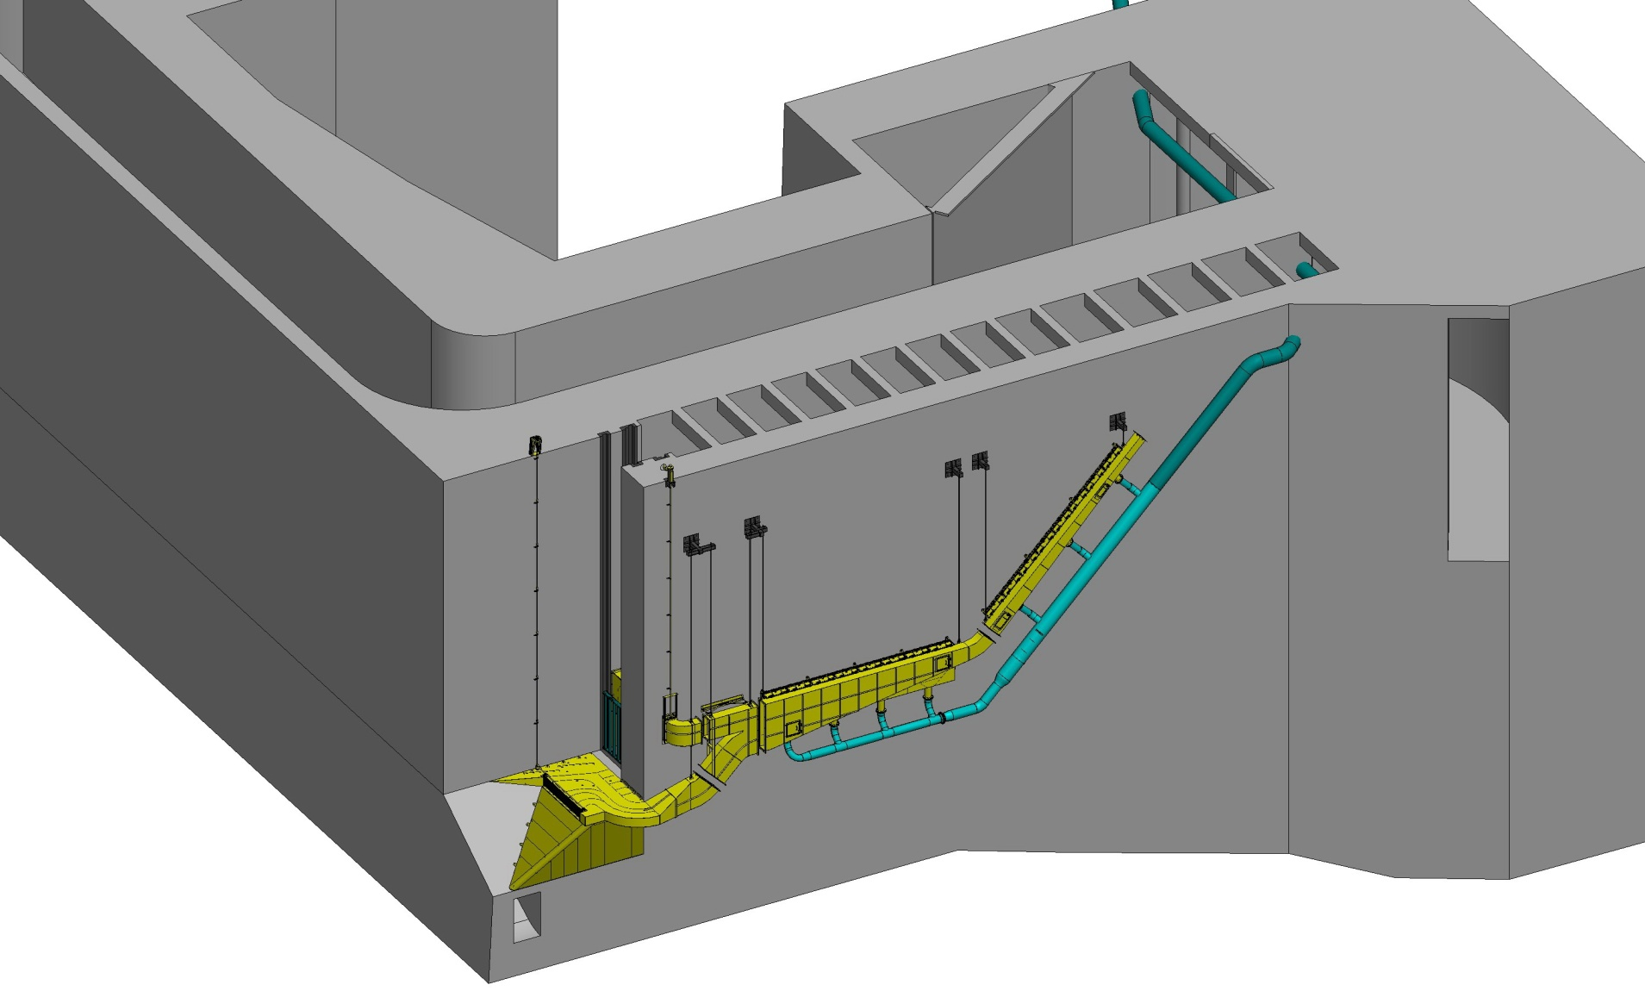
1
2
3
4
5
6
7
9
8
North Upstream Entrance (NUE)
North Downstream Entrance (NDE)
Junction Pool
Transition Pool
NDE-NUE Transportation Channel

- Upper Entrance
- Lower Entrance
- Thimble, Closure Gate, and Elbow Flume Section
- Filler Plate
- Flow Splitter Flume Section
- Downstream “School Bus” Flume Section
- Upstream Flume Section
- Lamprey Flume System (LFS) & Lamprey Passage Structure (LPS) Junction (LPS not shown)
- Gravity Water Supply Pipe

Figure 2. Isometric rendering of the Bonneville Washington Shore Lamprey Flume System. The boil of water and air being investigated has been seen at the water surface, just above the area circled in red. The four gaps between flume sections (yellow) are where PIT antennas are located. The micro ROV will be deployed via an access hatch in the Upstream Flume Section (7).

Table 1. Daily window counts of adult salmonids, Pacific Lamprey, and shad at Bonneville Dam from July 8-12 (2004-2012). *Lamprey counts do not include fish that passed via Lamprey Passage Structures (LPS) or fish that passed at night.

Mean Daily Fish Counts at Bonneville Dam (July 8-12)
Year | Chinook | Steelhead | Sockeye | Shad | Lamprey*
2004 | 1412 | 1916 | 1055 | 7384 | 800
2005 | 899 | 1525 | 753 | 5211 | 437
2006 | 1180 | 1146 | 335 | 7131 | 697
2007 | 768 | 1189 | 208 | 3578 | 760
2008 | 824 | 2796 | 733 | 5355 | 214
2009 | 999 | 1474 | 1054 | 880 | 100
2010 | 1318 | 5864 | 4138 | 1214 | 125
2011 | 1839 | 1224 | 4325 | 5380 | 132
2012 | 1280 | 1413 | 5337 | 2521 | 382
Mean | 1169 | 2061 | 1993 | 4295 | 405

